ĐỀ SỐ 2:
Read the following advertisement and mark the letter A, B, C and D on your answer sheet to indicate the option that best fits each of the numbered blanks from 1 to 6
Preserving Vietnam's Cultural Heritage for Future Generations
Vietnam has a rich cultural heritage, and preserving it is crucial for future generations. To conserve this heritage, the government and people must collaborate. Many of Vietnam's (1) _______ customs, monuments, and folk art forms are (2) ______ risk due to modernization and urbanization. Through education and awareness programs, citizens can learn to appreciate and protect (3) _______. Monuments and artifacts, (4)________by ancient designs, must be maintained and restored by experts. (5) _______ the rules of preservation, we can ensure that Vietnam’s cultural treasures will survive for years to come. Preservation efforts involve both local and international collaboration, encouraging the exchange of knowledge and techniques. It is important (6) ________ the significance of these traditions so they are not forgotten as the world moves forward.
(Adapted from learning news)
Câu 1: A. traditional B. traditionally C. tradition D. traditions
Câu 2: A. of B. at C. by D. to
Câu 3: A. cultural their heritage B. cultural heritage their
C. their cultural heritage D. heritage their cultural
Câu 4: A. which inspiring B. inspiring C. was inspired D. inspired
Câu 5: A. Doing B. Making C. Following D. Catching
Câu 6: A. to understanding B. understand C. understanding D. to understand
Read the following leaflet and mark the letter A, B, C or D on your answer sheet to indicate the option that best fits each of the numbered blanks from 7 to 12.
Preserving Vietnam’s Cultural Heritage
• Vietnam is home to a rich and diverse cultural heritage, which includes ancient traditions, monuments, and folk art. (7) _______ experts, preserving this heritage is essential for maintaining our identity and passing on valuable knowledge to future generations.
• The (8) ________ of cultural sites at risk due to urbanization and climate change is growing, which (9) _______ immediate action. We must focus on educating the public and raising awareness about the importance of conservation.
• (10) _______ efforts, such as restoring historical sites and safeguarding intangible heritage like traditional music, are also crucial. Cultural (11) _______ helps protect our identity and ensures that Vietnam’s unique history continues to thrive. Heritage (12) ________ is not only a responsibility for the government but also for every citizen.
Câu 7. A. Thanks to B. In addition to C. On account of D. According to
Câu 8. A. portion B. item C. number D. amount
Câu 9. A. calls for B. stands out C. keeps up D. focuses on
Câu 10. A. Others B. Other C. The others D. Another
Câu 11. A. preservation B. relaxation C. imagination D. integration
Câu 12. A. benefit B. site C. conservation D. service
Mark the letter A, B, C or D on your answer sheet to indicate the best arrangement of utterances or sentences to make a meaningful exchange or text in each of the following questions from 13 to 17.
Câu 13
a. Mark: Hi, Nam! Thanks. You're still very involved in preserving Vietnamese heritage, aren't you?
b. Nam: Hi, Mark! It's great to see you again. You still have that Vietnamese spirit!
c. Nam: That's right! I regularly attend workshops and events about Vietnamese culture.
A. c-a-b B. b-c-a C. c-b-a D. b-a-c
Câu 14
a. Alex: Why volunteer at those events?
b. Alex: How are you planning to preserve Vietnamese culture?
c. Alex: I see, but I think it's hard to make a real impact. I’m not sure if I would get involved.
d. Sue: I'm going to volunteer at cultural heritage events.
e. Sue: They help spread awareness about our traditions, and it's a way to connect with the younger generation.
A. b-d-a-e-c B. c-e-d-b-a C. d-b-a-e-c D. b-d-e-a-c
Câu 15
Hi Quan,
a. It’s exciting to learn about our culinary heritage, but I’m currently focused on learning Vietnamese folk music, so I don’t have time to join the cooking class right now.
b. But it was really enjoyable to watch the class preview video.
c. Thanks also for the link to the website with recipes for traditional Vietnamese dishes — I’ll definitely try them out when I have time.
d. Thanks for the recommendation about the traditional Vietnamese cooking class.
e. You know, it would be nice if we could cook and play music together sometime. What do you think?
Write back soon,
Tu
A. d-b-a-c-e B. d-a-b-c-e C. a-d-b-c-e D. a-c-d-b-e
Câu 16
a. Although creating lesson plans and adapting materials for online platforms can take time, seeing students learn and appreciate our culture makes it all worthwhile.
b. My deep interest in preserving Vietnamese traditions led me to pursue a career in cultural education.
c. Teaching online has been a great way to reach more students and share our heritage with people around the world.
d. All in all, I’m thrilled with my work, as it allows me to keep our traditions alive and pass them on to the next generation.
e. Over the last few years, I’ve been teaching traditional Vietnamese arts, such as calligraphy and folk music, to younger generations in schools and workshops.
(Adapted from Bright)
A. b-e-c-a-d B. a-b-c-d-e C. b-c-d-a-e D. c-a-d-b-e
Câu 17
a. However, despite the revival, many younger generations still find it difficult to connect with folk music, as modern pop culture dominates their daily lives.
b. Many traditional instruments, like the đàn bầu and đàn tranh, were almost forgotten but have now regained popularity through cultural festivals and performances.
c. This resurgence has brought more attention to Vietnam’s musical heritage, with both locals and tourists attending performances, which helps boost cultural tourism.
d. Vietnamese folk music has undergone a remarkable revival in recent years.
e. The popularity of folk music has also contributed to the growing interest in traditional Vietnamese culture, leading to more events and initiatives aimed at preserving it.
(Adapted from i-Learn Smart World)
A. c-a-e-b-d B. d-c-a-b-e C. d-e-a-b-c D. d-b-c-e-a
Read the following passage about Vietnamese culture and mark the letter A, B, C or D on your answer sheet to indicate the option that best fits each of the numbered blanks from 18 to 22.
Vietnamese culture has a rich history that needs to be preserved for future generations. Over the years, various efforts (18) _________. Many ancient practices and monuments, such as the imperial architecture in Hue, have been protected by the government and local communities. This has been achieved through strict laws and educational campaigns aimed at raising awareness. One of the challenges, however, is maintaining these traditions while adapting to modern life, (19) _________. For example, the increasing use of technology in daily life can sometimes overshadow traditional customs, (20) __________.
Because of this, it is crucial to balance progress with preservation. Measures have been taken, such as organizing cultural festivals and workshops (21) _________. However, some people still do not fully appreciate the importance of protecting cultural identity. In many cases, families in urban areas (22) _________. This issue needs to be addressed before the cultural richness of Vietnam fades away.
(Adapted from Friends Global)
Câu 18:
A. have been made to safeguard traditional customs, arts, and heritage sites
B. were made to safeguarding traditional customs, arts, and heritage sites
C. will have made to be safeguarded traditional customs, arts, and heritage sites
D. were being made to have been safeguard traditional customs, arts, and heritage sites
Câu 19:
A. when often shares new influences and changes
B. in which often takes new influences and changes
C. that often supports new influences and changes
D. which often brings new influences and changes
Câu 20:
A. when leading to the risk of cultural loss. B. led to a risk of the culture of loss.
C. leading to a risk of cultural loss. D. was leading to a risk of loss of culture.
Câu 21:
A. not to teach younger generations in their heritage
B. to teach younger generations about their heritage
C. to teaching younger generations for their heritage
D. not to teaching younger generations of their heritage
Câu 22:
A. found it difficult to pass down values of tradition to their children
B. will find it difficult to passing down traditional values to their children
C. find difficult to pass down the traditional of values to their children
D. have found it difficult to pass down traditional values to their children
Read the following passage about Preserving Vietnam's Cultural Heritage in the Age of Modernization and mark the letter A, B, C or D on your answer sheet to indicate the best answer to each of the following questions from 23 to 30.
Vietnam has a long and rich cultural heritage with many traditional customs, arts, and monuments that reflect its history and identity. Over the years, the Vietnamese government has made significant efforts to preserve and protect this heritage. A key part of these efforts is the protection of ancient monuments, such as the Imperial City in Hue, and traditional arts like water puppetry. Additionally, various educational campaigns are conducted to raise public awareness about the importance of safeguarding cultural identity.
Despite these efforts, there are challenges in balancing modernization with cultural preservation. For example, the rapid growth of urbanization and the adoption of modern technologies have led to the decline of some traditional practices. As a result, many young people, especially in large cities, may not fully appreciate the value of their cultural heritage.
In response to this challenge, the government has developed strategies to safeguard these traditions while adapting to the demands of the modern world. One approach is to integrate cultural education into school curriculums. Many schools now offer courses about Vietnamese history, traditional crafts, and local folklore. Cultural festivals and workshops are also organized to involve the younger generation in preserving their traditions.
Moreover, the Vietnamese government is increasingly using digital platforms to promote and protect cultural practices. Virtual museums and online exhibitions are helping people access and appreciate the nation's history and art from anywhere in the world. This approach is particularly effective in reaching the younger generation, who are more familiar with digital media. With these efforts, Vietnam hopes to ensure that its cultural identity remains strong and vibrant in the face of global change.
(Adapted from vietnamese news)
Câu 23: Which of the following is NOT mentioned as one of the efforts to protect Vietnamese culture?
A. The preservation of ancient monuments. B. Organizing cultural festivals and workshops.
C. Teaching Vietnamese culture in schools. D. Increasing the use of modern technologies.
Câu 24: The word “heritage” in paragraph 1 is OPPOSITE in meaning to:
A. Past. B. Modern. C. Tradition. D. History.
Câu 25: The word “their” in paragraph 2 refers to:
A. Educational campaigns. B. Traditional practices. C. Many young people. D. Urban areas.
Câu 26: The word “strategies” in paragraph 3 could be best replaced by:
A. Methods. B. Results. C. Challenges. D. Problems.
Câu 27: Which of the following best paraphrases the underlined sentence: “Vietnam hopes to ensure that its cultural identity remains strong and vibrant in the face of global change”?
A. Vietnam is trying to protect its cultural identity in the face of globalization.
B. Vietnam does not want to lose its cultural identity to the changing world.
C. Vietnam believes that global changes will not affect its cultural identity.
D. Vietnam is indifferent to the influence of globalization on its culture.
Câu 28: Which of the following is TRUE according to the passage?
A. Many young people appreciate traditional practices in urban areas.
B. The Vietnamese government is working to integrate cultural education into school curriculums.
C. The Vietnamese government opposes the use of technology to protect culture.
D. Cultural festivals are not used as a method of protecting culture.
Câu 29: In which paragraph does the writer mention a present causal relationship?
A. Paragraph 1. B. Paragraph 2. C. Paragraph 3. D. Paragraph 4.
Câu 30: In which paragraph does the writer explore modern methods for maintaining endangered cultures?
A. Paragraph 1. B. Paragraph 2. C. Paragraph 3. D. Paragraph 4.
Read the following passage about preserving Vietnamese culture and mark the letter A, B, C or D on your answer sheet to indicate the best answer to each of the following questions from 31 to 40.
[I] In recent years, the issue of preserving Vietnamese culture has gained considerable attention, as rapid modernization and globalization pose challenges to traditional customs. [II] The government has started implementing stronger measures to protect and promote Vietnam’s cultural heritage, making this a central part of national policies. [III] These measures include strengthening laws against the destruction of historical sites, supporting traditional art forms, and promoting cultural education. [IV] These efforts are crucial because maintaining cultural diversity not only preserves national identity but also fosters unity and a sense of belonging among citizens.
Several laws have been enacted to protect Vietnam’s cultural landmarks from commercial exploitation and natural disasters. Additionally, there has been increased funding for the preservation of ancient temples, pagodas, and other historical monuments. Traditional arts such as water puppetry, folk music, and dance are receiving more support through government-sponsored programs. Education programs are also being introduced to raise awareness among the younger generation about the importance of cultural preservation.
While these government actions are necessary, the success of cultural preservation also depends on the involvement of local communities. Citizens must actively participate in safeguarding their cultural practices, supporting their local artisans, and respecting their heritage sites.
In conclusion, the preservation of Vietnamese culture is a vital issue that requires cooperation from all sectors. By combining government policies, community involvement, and public awareness, Vietnam can successfully protect its rich cultural heritage for future generations.
(Adapted from www.reuters.com/legal/)
Câu 31: Where in paragraph 1 does the following sentence best fit?
"Efforts to preserve culture have become a key focus of national policies."
A. [I] B. [II] C. [III] D. [IV]
Câu 32: The phrase "strengthening laws" in paragraph 1 could be best replaced by ____.
A. enforcing stricter regulations B. introducing financial support
C. spreading awareness D. developing new traditions
Câu 33: The word "their" in paragraph 3 refers to ____.
A. laws’ B. citizens’ C. historical monuments’ D. community efforts’
Câu 34: According to paragraph 2, which of the following is NOT mentioned as a measure to protect Vietnamese culture?
A. Protecting historical monuments B. Supporting traditional art forms
C. Educating the younger generation D. Improving the quality of tourism services
Câu 35: Which of the following best summarizes paragraph 3?
A. The government’s initiatives to preserve cultural heritage include protecting historical landmarks and promoting traditional arts.
B. Community involvement is crucial for the success of cultural preservation programs.
C. The preservation of cultural practices depends on the government’s support for education.
D. Education programs are the most effective way to raise awareness about cultural preservation.
Câu 36: The word "destruction" in paragraph 1 is OPPOSITE in meaning to ____.
A. preservation B. renovation C. demolition D. abandonment
Câu 37: Which of the following is TRUE according to the passage?
A. The government is actively taking steps to protect Vietnam's cultural heritage.
B. The younger generation is not interested in cultural preservation.
C. Local communities are not involved in preserving traditional practices.
D. The government has stopped funding for cultural preservation programs.
Câu 38: Which of the following best paraphrases the underlined sentence "The preservation of Vietnamese culture is a vital issue that requires cooperation from all sectors" in paragraph 4?
A. Preserving Vietnamese culture is essential and demands collective efforts from everyone.
B. Cultural preservation is less important than other national issues and does not need widespread involvement.
C. The government is the only body responsible for the preservation of Vietnamese culture.
D. Only the younger generation can solve the problems of cultural preservation in Vietnam.
Câu 39: Which of the following can be inferred from the passage?
A. Government actions alone can successfully preserve Vietnamese culture.
B. Public participation is vital for the effectiveness of cultural preservation efforts.
C. Cultural preservation is no longer a priority for the Vietnamese government.
D. Local artisans are not interested in preserving traditional arts.
Câu 40: Which of the following best summarizes the passage?
A. The government, local communities, and the public must work together to protect and preserve Vietnam’s cultural heritage through stronger laws and educational programs.
B. The government alone can solve the issue of cultural preservation through financial support and stricter regulations.
C. The younger generation must be educated about cultural preservation, but government action is unnecessary.
D. Public awareness programs are the only necessary measures to preserve Vietnamese culture.

LỜI GIẢI CHI TIẾT

Read the following advertisement and mark the letter A, B, C and D on your answer sheet to indicate the option that best fits each of the numbered blanks from 1 to 6

Preserving Vietnam's Cultural Heritage for Future Generations
Vietnam has a rich cultural heritage, and preserving it is crucial for future generations. To conserve this heritage, the government and people must collaborate. Many of Vietnam's (1) customs, monuments, and folk art forms are (2) risk due to modernization and urbanization. Through education and awareness programs, citizens can learn to appreciate and protect (3) . Monuments and artifacts, (4) by ancient designs, must be maintained and restored by experts. (5) the rules of preservation, we can ensure that Vietnam’s cultural treasures will survive for years to come. Preservation efforts involve both local and international collaboration, encouraging the exchange of knowledge and techniques. It is important (6) the significance of these traditions so they are not forgotten as the world moves forward.
(Adapted from learning news)
Câu 1: A. traditional B. traditionally C. tradition D. traditions
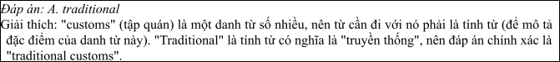
Câu 2: A. of B. at C. by D. to
Câu 3: A. cultural their heritage B. cultural heritage their
C. their cultural heritage D. heritage their cultural
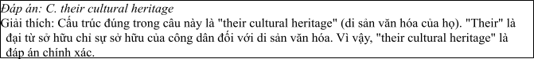
Câu 4: A. which inspiring B. inspiring C. was inspired D. inspired
Câu 5: A. Doing B. Making C. Following D. Catching
Câu 6: A. to understanding B. understand C. understanding D. to understand
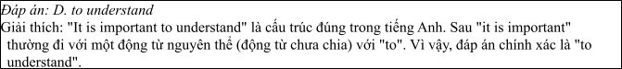
Read the following leaflet and mark the letter A, B, C or D on your answer sheet to indicate the option that best fits each of the numbered blanks from 7 to 12.

Preserving Vietnam’s Cultural Heritage
• Vietnam is home to a rich and diverse cultural heritage, which includes ancient traditions, monuments, and folk art. (7) experts, preserving this heritage is essential for maintaining our identity and passing on valuable knowledge to future generations.
• The (8) of cultural sites at risk due to urbanization and climate change is growing, which
(9) immediate action. We must focus on educating the public and raising awareness about the importance of conservation.
• (10) efforts, such as restoring historical sites and safeguarding intangible heritage like traditional music, are also crucial. Cultural (11) helps protect our identity and ensures that Vietnam’s unique history continues to thrive. Heritage (12) is not only a responsibility for the government but also for every citizen.
Câu 7. A. Thanks to B. In addition to C. On account of D. According to
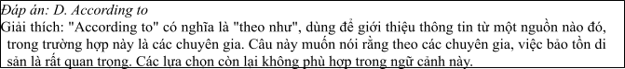
Câu 8. A. portion B. item C. number D. amount
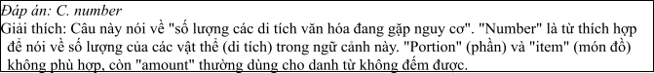
Câu 9. A. calls for B. stands out C. keeps up D. focuses on
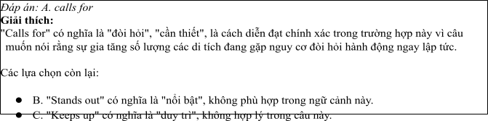
Câu 10. A. Others B. Other C. The others D. Another
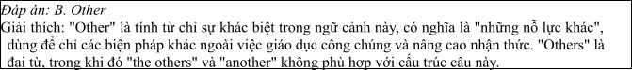
Câu 11. A. preservation B. relaxation C. imagination D. integration
Câu 12. A. benefit B. site C. conservation D. service
Mark the letter A, B, C or D on your answer sheet to indicate the best arrangement of utterances or sentences to make a meaningful exchange or text in each of the following questions from 13 to 17.

Câu 13
1. Mark: Hi, Nam! Thanks. You're still very involved in preserving Vietnamese heritage, aren't you?
2. Nam: Hi, Mark! It's great to see you again. You still have that Vietnamese spirit!
3. Nam: That's right! I regularly attend workshops and events about Vietnamese culture.
A. c-a-b B. b-c-a C. c-b-a D. b-a-c
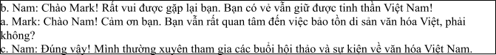

Câu 14
1. Alex: Why volunteer at those events?
2. Alex: How are you planning to preserve Vietnamese culture?
3. Alex: I see, but I think it's hard to make a real impact. I’m not sure if I would get involved.
4. Sue: I'm going to volunteer at cultural heritage events.
5. Sue: They help spread awareness about our traditions, and it's a way to connect with the younger generation.
A. b-d-a-e-c B. c-e-d-b-a C. d-b-a-e-c D. b-d-e-a-c
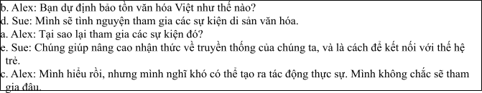

Câu 15
Hi Quan,
1. It’s exciting to learn about our culinary heritage, but I’m currently focused on learning Vietnamese folk music, so I don’t have time to join the cooking class right now.
2. But it was really enjoyable to watch the class preview video.
3. Thanks also for the link to the website with recipes for traditional Vietnamese dishes — I’ll definitely
try them out when I have time.
4. Thanks for the recommendation about the traditional Vietnamese cooking class.
5. You know, it would be nice if we could cook and play music together sometime. What do you think? Write back soon,
Tu
A. d-b-a-c-e B. d-a-b-c-e C. a-d-b-c-e D. a-c-d-b-e
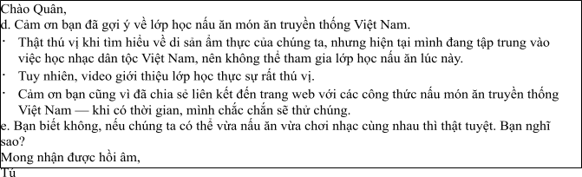

Câu 16
1. Although creating lesson plans and adapting materials for online platforms can take time, seeing students learn and appreciate our culture makes it all worthwhile.
2. My deep interest in preserving Vietnamese traditions led me to pursue a career in cultural education.
3. Teaching online has been a great way to reach more students and share our heritage with people around the world.
4. All in all, I’m thrilled with my work, as it allows me to keep our traditions alive and pass them on to
the next generation.
5. Over the last few years, I’ve been teaching traditional Vietnamese arts, such as calligraphy and folk
music, to younger generations in schools and workshops.
(Adapted from Bright)
A. b-e-c-a-d B. a-b-c-d-e C. b-c-d-a-e D. c-a-d-b-e
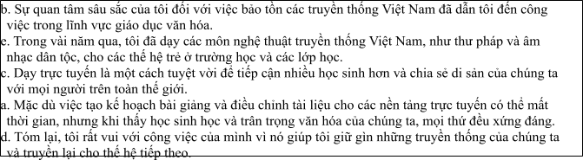

Câu 17
1. However, despite the revival, many younger generations still find it difficult to connect with folk music, as modern pop culture dominates their daily lives.
2. Many traditional instruments, like the đàn bầu and đàn tranh, were almost forgotten but have now
regained popularity through cultural festivals and performances.
3. This resurgence has brought more attention to Vietnam’s musical heritage, with both locals and tourists attending performances, which helps boost cultural tourism.
4. Vietnamese folk music has undergone a remarkable revival in recent years.
5. The popularity of folk music has also contributed to the growing interest in traditional Vietnamese culture, leading to more events and initiatives aimed at preserving it.
(Adapted from i-Learn Smart World)
A. c-a-e-b-d B. d-c-a-b-e C. d-e-a-b-c D. d-b-c-e-a
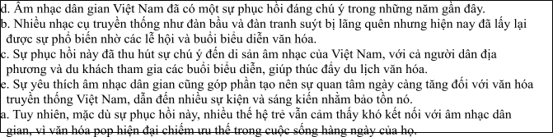
Read the following passage about Vietnamese culture and mark the letter A, B, C or D on your answer sheet to indicate the option that bestfits each of the numbered blanksfrom 18 to 22.
Vietnamese culture has a rich history that needs to be preserved for future generations. Over the years, various efforts (18) . Many ancient practices and monuments, such as the imperial architecture in Hue, have been protected by the government and local communities. This has been achieved through strict laws and educational campaigns aimed at raising awareness. One of the challenges, however, is maintaining these traditions while adapting to modern life, (19) . For example, the increasing use of technology in daily life can sometimes overshadow traditional customs, (20) .
Because of this, it is crucial to balance progress with preservation. Measures have been taken, such as organizing cultural festivals and workshops (21) . However, some people still do not fully
appreciate the importance of protecting cultural identity. In many cases, families in urban areas (22)
. This issue needs to be addressed before the cultural richness of Vietnam fades away.
(Adapted from Friends Global)
Câu 18:
1. have been made to safeguard traditional customs, arts, and heritage sites
2. were made to safeguarding traditional customs, arts, and heritage sites
3. will have made to be safeguarded traditional customs, arts, and heritage sites
4. were being made to have been safeguard traditional customs, arts, and heritage sites
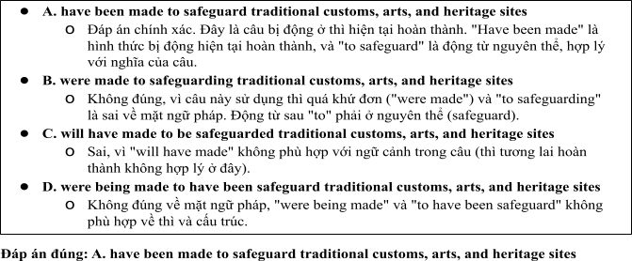

Câu 19:
1. when often shares new influences and changes
2. in which often takes new influences and changes
3. that often supports new influences and changes
4. which often brings new influences and changes
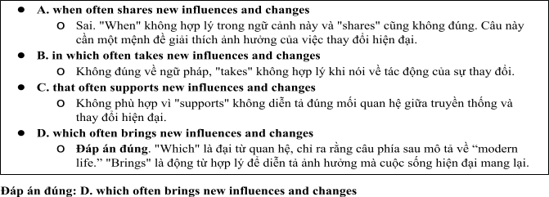

Câu 20:
A. when leading to the risk of cultural loss. B. led to a risk of the culture of loss.
C. leading to a risk of cultural loss. D. was leading to a risk of loss of culture.

Câu 21:
1. not to teach younger generations in their heritage
2. to teach younger generations about their heritage
3. to teaching younger generations for their heritage
4. not to teaching younger generations of their heritage
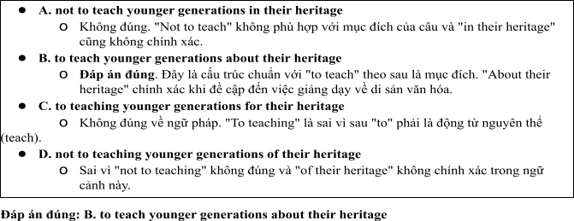

Câu 22:
1. found it difficult to pass down values of tradition to their children
2. will find it difficult to passing down traditional values to their children
3. find difficult to pass down the traditional of values to their children
4. have found it difficult to pass down traditional values to their children
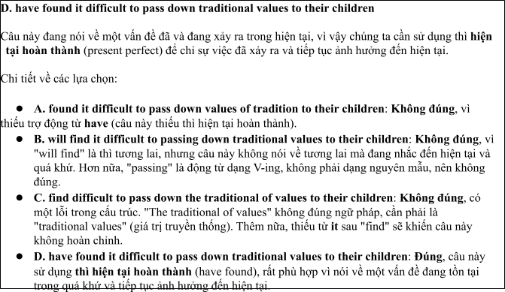
Read the following passage about Preserving Vietnam's Cultural Heritage in the Age of Modernization and mark the letter A, B, C or D on your answer sheet to indicate the best answer to each of the following questions from 23 to 30.
Vietnam has a long and rich cultural heritage with many traditional customs, arts, and monuments that reflect its history and identity. Over the years, the Vietnamese government has made significant efforts to preserve and protect this heritage. A key part of these efforts is the protection of ancient monuments, such as the Imperial City in Hue, and traditional arts like water puppetry. Additionally, various educational campaigns are conducted to raise public awareness about the importance of safeguarding cultural identity.
Despite these efforts, there are challenges in balancing modernization with cultural preservation. For example, the rapid growth of urbanization and the adoption of modern technologies have led to the decline of some traditional practices. As a result, many young people, especially in large cities, may not fully appreciate the value of their cultural heritage.
In response to this challenge, the government has developed strategies to safeguard these traditions while adapting to the demands of the modern world. One approach is to integrate cultural education into school curriculums. Many schools now offer courses about Vietnamese history, traditional crafts, and local folklore. Cultural festivals and workshops are also organized to involve the younger generation in preserving their traditions.
Moreover, the Vietnamese government is increasingly using digital platforms to promote and protect cultural practices. Virtual museums and online exhibitions are helping people access and appreciate the nation's history and art from anywhere in the world. This approach is particularly effective in reaching the younger generation, who are more familiar with digital media. With these efforts, Vietnam hopes to ensure that its cultural identity remains strong and vibrant in the face of global change.
(Adapted from vietnamese news)
Câu 23. Which of the following is NOT mentioned as one of the efforts to protect Vietnamese culture?
A. The preservation of ancient monuments. B. Organizing cultural festivals and workshops.
C. Teaching Vietnamese culture in schools. D. Increasing the use of modern technologies.
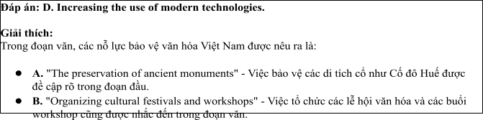
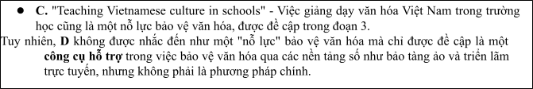
Câu 24. The word “heritage” in paragraph 1 is OPPOSITE in meaning to:
A. Past. B. Modern. C. Tradition. D. History.
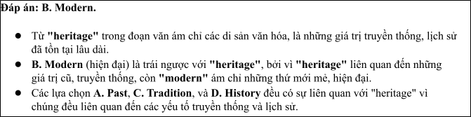
Câu 25. The word “their” in paragraph 2 refers to:
A. Educational campaigns. B. Traditional practices. C. Many young people. D. Urban areas.
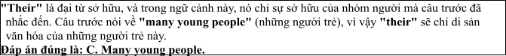
Câu 26. The word “strategies” in paragraph 3 could be best replaced by:
A. Methods. B. Results. C. Challenges. D. Problems.
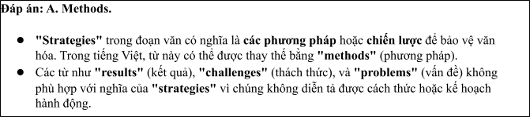
Câu 27. Which of the following best paraphrases the underlined sentence: “Vietnam hopes to ensure

that its cultural identity remains strong and vibrant in the face of global change”?
1. Vietnam is trying to protect its cultural identity in the face of globalization.
2. Vietnam does not want to lose its cultural identity to the changing world.
3. Vietnam believes that global changes will not affect its cultural identity.
4. Vietnam is indifferent to the influence of globalization on its culture.
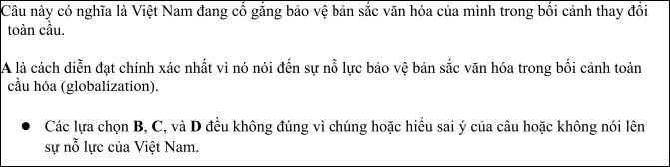
Câu 28. Which of the following is TRUE according to the passage?
1. Many young people appreciate traditional practices in urban areas.
2. The Vietnamese government is working to integrate cultural education into school curriculums.
3. The Vietnamese government opposes the use of technology to protect culture.
4. Cultural festivals are not used as a method of protecting culture.
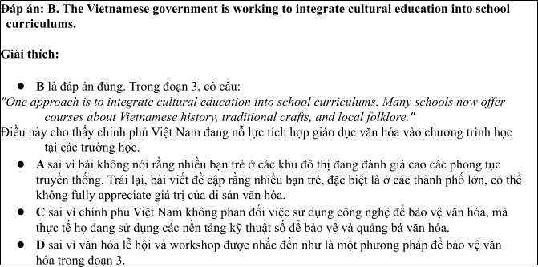
Câu 29. In which paragraph does the writer mention a present causal relationship?
A. Paragraph 1. B. Paragraph 2. C. Paragraph 3. D. Paragraph 4.
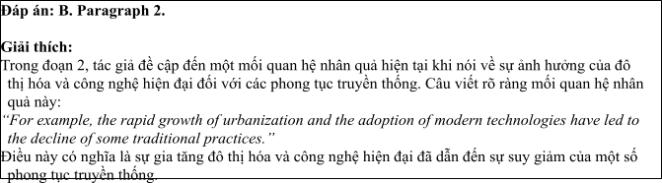
Câu 30. In which paragraph does the writer explore modern methods for maintaining endangered cultures?
A. Paragraph 1. B. Paragraph 2. C. Paragraph 3. D. Paragraph 4.
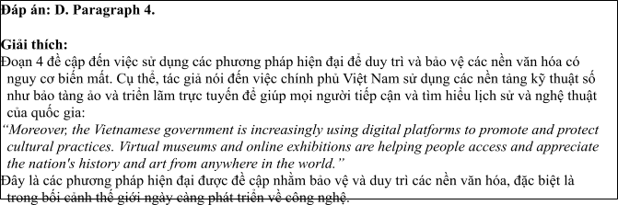
Read the following passage about preserving Vietnamese culture and mark the letter A, B, C or D on your answer sheet to indicate the best answer to each of the following questions from 31 to 40.
[I] In recent years, the issue of preserving Vietnamese culture has gained considerable attention, as rapid modernization and globalization pose challenges to traditional customs. [II] The government has started implementing stronger measures to protect and promote Vietnam’s cultural heritage, making this a central part of national policies. [III] These measures include strengthening laws against the destruction of historical sites, supporting traditional art forms, and promoting cultural education. [IV] These efforts are crucial because maintaining cultural diversity not only preserves national identity but also fosters unity and a sense of belonging among citizens.
Several laws have been enacted to protect Vietnam’s cultural landmarks from commercial exploitation and natural disasters. Additionally, there has been increased funding for the preservation of ancient temples, pagodas, and other historical monuments. Traditional arts such as water puppetry, folk music, and dance are receiving more support through government-sponsored programs. Education programs are also being introduced to raise awareness among the younger generation about the importance of cultural preservation.
While these government actions are necessary, the success of cultural preservation also depends on the involvement of local communities. Citizens must actively participate in safeguarding their cultural practices, supporting their local artisans, and respecting their heritage sites.
In conclusion, the preservation of Vietnamese culture is a vital issue that requires cooperation from all sectors. By combining government policies, community involvement, and public awareness, Vietnam can successfully protect its rich cultural heritage for future generations.
(Adapted from www.reuters.com/legal/)
Câu 31: Where in paragraph 1 does the following sentence best fit?

"Efforts to preserve culture have become a key focus of national policies."
A. [I] B. [II] C. [III] D. [IV]
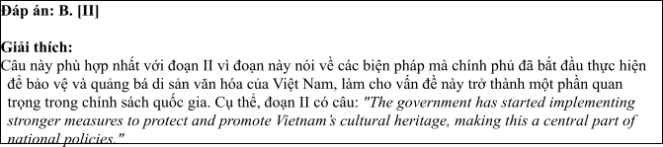
Câu 32: The phrase "strengthening laws" in paragraph 1 could be best replaced by .
A. enforcing stricter regulations B. introducing financial support
C. spreading awareness D. developing new traditions
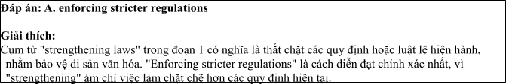
Câu 33: The word "their" in paragraph 3 refers to .
A. laws’ B. citizens’ C. historical monuments’ D. community efforts’
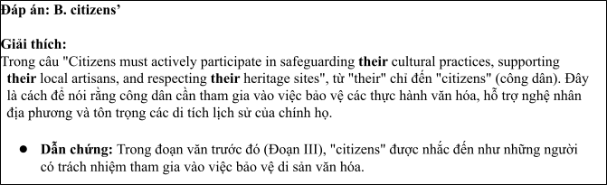
Câu 34: According to paragraph 2, which of the following is NOT mentioned as a measure to protect Vietnamese culture?
A. Protecting historical monuments B. Supporting traditional art forms
C. Educating the younger generation D. Improving the quality of tourism services
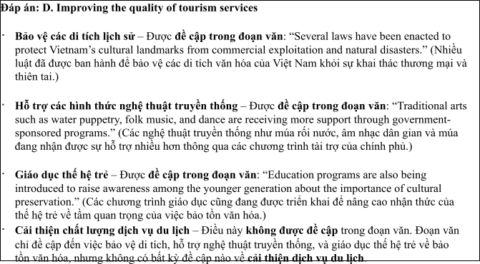
Câu 35: Which of the following best summarizes paragraph 3?
1. The government’s initiatives to preserve cultural heritage include protecting historical landmarks and
promoting traditional arts.
2. Community involvement is crucial for the success of cultural preservation programs.
3. The preservation of cultural practices depends on the government’s support for education.
4. Education programs are the most effective way to raise awareness about cultural preservation.
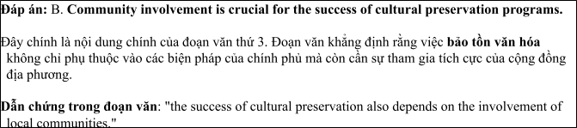
Câu 36: The word "destruction" in paragraph 1 is OPPOSITE in meaning to .
A. preservation B. renovation C. demolition D. abandonment
Câu 37: Which of the following is TRUE according to the passage?
1. The government is actively taking steps to protect Vietnam's cultural heritage.
2. The younger generation is not interested in cultural preservation.
3. Local communities are not involved in preserving traditional practices.
4. The government has stopped funding for cultural preservation programs.
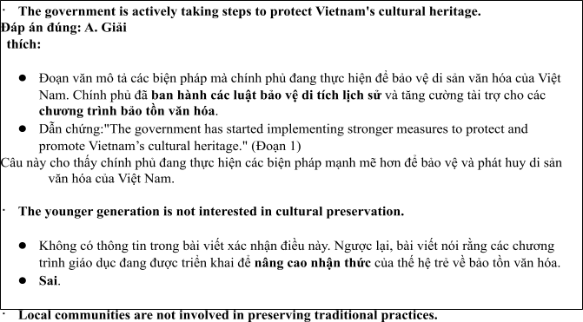
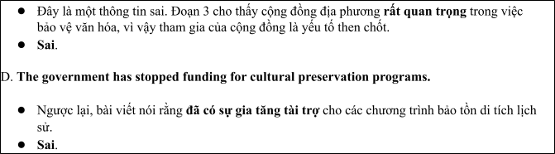
Câu 38: Which of the following best paraphrases the underlined sentence "The preservation of Vietnamese culture is a vital issue that requires cooperation from all sectors" in paragraph 4?
1. Preserving Vietnamese culture is essential and demands collective efforts from everyone.
2. Cultural preservation is less important than other national issues and does not need widespread involvement.
3. The government is the only body responsible for the preservation of Vietnamese culture.
4. Only the younger generation can solve the problems of cultural preservation in Vietnam.
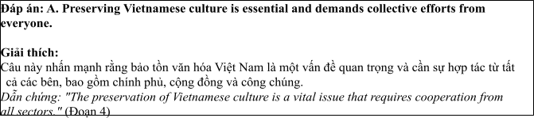
Câu 39: Which of the following can be inferred from the passage?
1. Government actions alone can successfully preserve Vietnamese culture.
2. Public participation is vital for the effectiveness of cultural preservation efforts.
3. Cultural preservation is no longer a priority for the Vietnamese government.
4. Local artisans are not interested in preserving traditional arts.
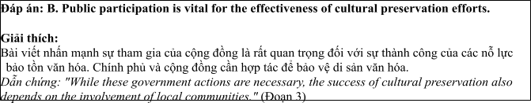
Câu 40: Which of the following best summarizes the passage?
1. The government, local communities, and the public must work together to protect and preserve
Vietnam’s cultural heritage through stronger laws and educational programs.
2. The government alone can solve the issue of cultural preservation through financial support and stricter regulations.
3. The younger generation must be educated about cultural preservation, but government action is unnecessary.
4. Public awareness programs are the only necessary measures to preserve Vietnamese culture.
